**DB2安装**

# db2 for linux下安装

## 上传安装介质并解压

将安装介质上传至需要安装的服务器：



解压缩：



将tar包解压：



## 安装前验证

cd 至server目录中：

输入：./db2prereqcheck -v 10.1.0.4

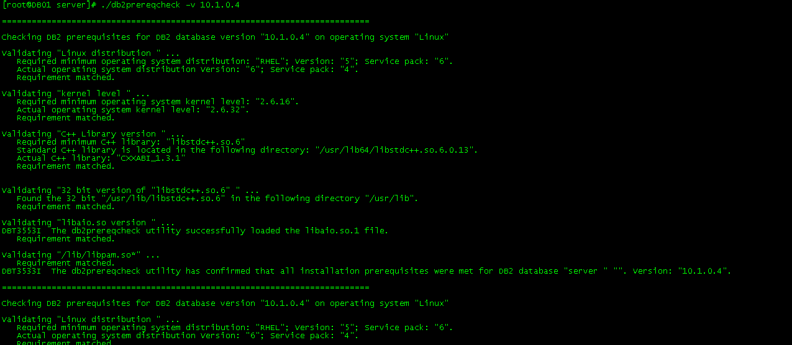

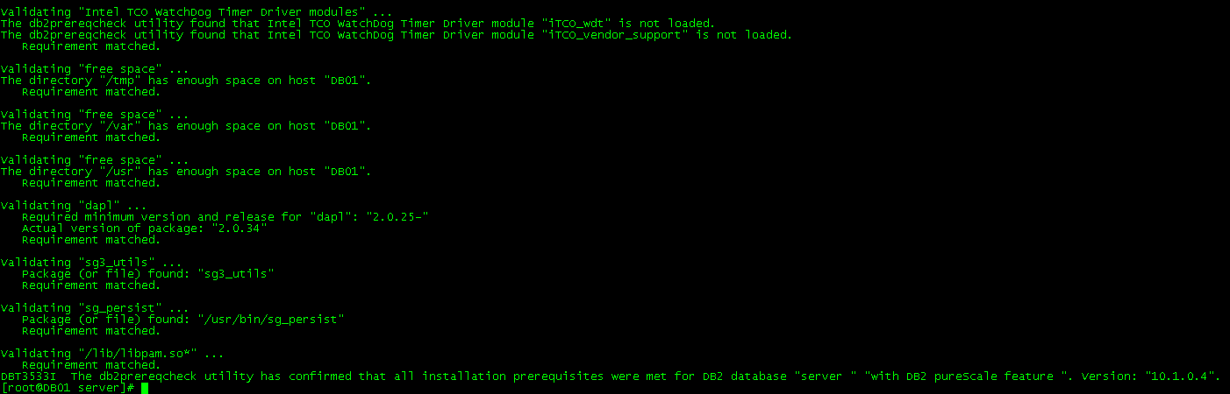

如果缺少补丁包，需要进行补丁包的安装：

yum -y install libstdc++.so.6

## 安装

输入：./db2_install

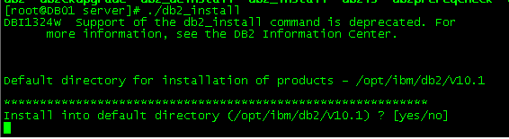

输入安装的目录，如果是默认目录，则输入yes：



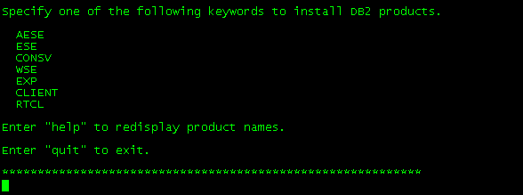

输入：ESE

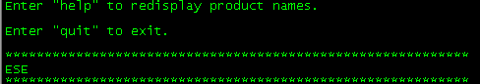

输入：no，不安装pureScale



安装成功：

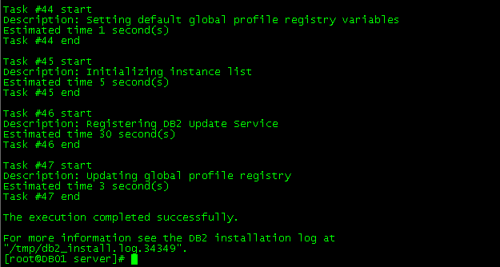

## 内核参数

### 修改系统内核

在 /etc/sysctl.conf 文件中添加如下信息：

## Start of Kernel IPC parameters for DB2

# shmmni:256 * <size of RAM in GB>

kernel.shmmni=65536

# shmmax:<size of RAM in bytes>

kernel.shmmax=270692089856

# shmall:2 * <size of RAM in the default system page size>

# default system page size: getconf PAGESIZE

kernel.shmall=132173872

#kernel.sem=<SEMMSL> <SEMMNS> <SEMOPM> <SEMMNI>

#kernel.sem=<250> <256000> <32> <256 * <size of RAM in GB>>

kernel.sem=250 256000 32 65536

# msgmni: 1024 * <size of RAM in GB>

kernel.msgmni=262144

# msgmax: 65536

kernel.msgmax=65536

# msgmnb: 65536

kernel.msgmnb=1300240

运行sysctl -p，以便从缺省文件/etc/sysctl.conf中装入sysctl设置。

运行ipcs -l显示当前的内核参数设置。

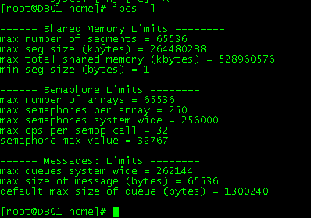

### 修改limits.conf文件

cat /etc/security/limits.conf

db2inst1 soft nproc 2047

db2inst1 hard nproc 16384

db2inst1 soft nofile 4096

db2inst1 hard nofile 65536

db2inst1 soft stack 10240

-- -1表示最大数据大小没有限制

db2inst1 hard data -1

-- -1表示最大数据大小没有限制

db2inst1 hard fsize -1

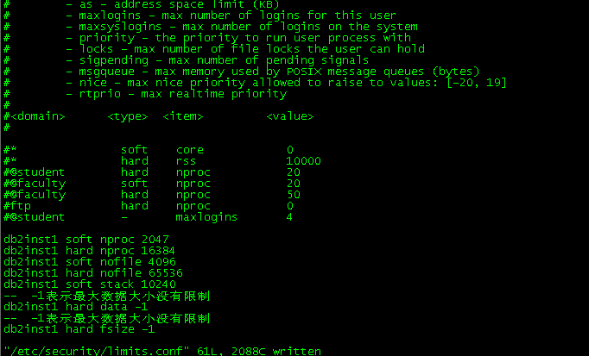

## 创建用户和组

创建用户组：groupadd -g 600 db2igrp1

groupadd -g 601 db2ifenc1

groupadd -g 602 etlgrp

创建用户：useradd -u 600 -g db2igrp1 db2inst1

passwd db2inst1

输入密码：db2inst1

useradd -u 601 -g db2ifenc1 db2fenc1

passwd db2fenc1

输入密码：db2fenc1

useradd -u 602 -g etlgrp etl

passwd etl

输入密码:etl

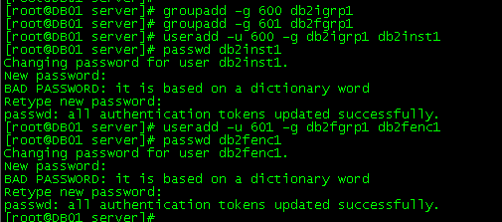



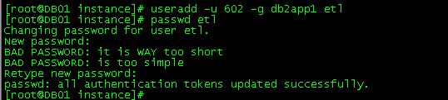

## 实例创建与配置

root用户登录：

/opt/ibm/db2/V10.1/instance/db2icrt -u db2fenc1 db2inst1

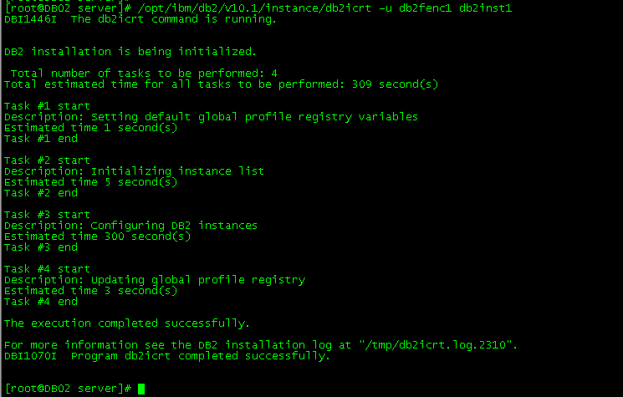

打开/etc/services文件,在后面添加：

db2c_db2inst1 50000/tcp



使用db2inst1用户登录：

执行：db2 update dbm cfg using SVCENAME db2c_db2inst1



[db2inst1@DB01 ~]$ db2set DB2COMM=tcpip

[db2inst1@DB01 ~]$ db2set DB2CODEPAGE=1386



## 创建数据库

启动实例：使用db2inst1用户登录

db2start



创建数据库:

db2 "create db etldb on /etl using codeset GBK territory CN"



## 创建缓冲池

缓冲池：

|  |  |  |  |
| --- | --- | --- | --- |
| **缓冲池名称** | **页大小** | **页数** | **总大小** |
| BP_DATA_32K | 32K | 131072 | 4G |
| BP_IDX_32K | 32K | 65536 | 2G |
| BP_DATA_8K | 8K | 262144 | 2G |
| BP_IDX_8K | 8K | 131072 | 1G |
| EOS32K | 32K | 65536 | 2G |
| EOS4K | 4K | 524288 | 2G |

使用db2inst1用户登录

db2 "CREATE BUFFERPOOL BP_DATA_32K SIZE 131072 PAGESIZE 32K"

db2 "CREATE BUFFERPOOL BP_IDX_32K SIZE 65536 PAGESIZE 32K "

db2 "CREATE BUFFERPOOL BP_DATA_8K SIZE 262144 PAGESIZE 8K"

db2 "CREATE BUFFERPOOL BP_IDX_8K SIZE 131072 PAGESIZE 8K"

db2 "CREATE BUFFERPOOL EOS32K SIZE 65536 PAGESIZE 32768"

db2 "CREATE BUFFERPOOL EOS4K SIZE 524288 PAGESIZE 4096"

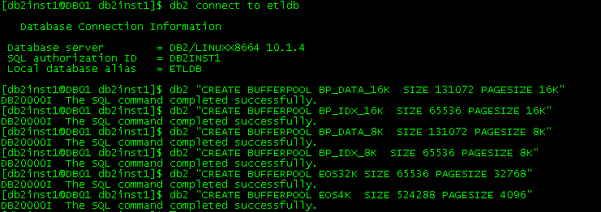

## 创建表空间

表空间规划：

|  |  |  |  |  |  |  |
| --- | --- | --- | --- | --- | --- | --- |
| 表空间 | 类型 | 页大小 | 页数 | 总大小 | 路径 | 缓冲池 |
| DATA_TBS1 | LARGE | 32k | 163840  163840 | 10G | /etl/db2inst1/etldb/tbsdata/DATA_TBS1_01.DBF  /etl/db2inst1/etldb/tbsdata/DATA_TBS1_02.DBF | BP_DATA_32K |
| IDX_TBS1 | LARGE | 32k | 163840 | 5G | /etl/db2inst1/etldb/tbsdata/IDX_TBS1_01.DBF | BP_IDX_32K |
| LONG_TBS1 | LARGE | 32k | 163840 | 5G | /etl/db2inst1/etldb/tbsdata/LONG_TBS1_01.DBF | BP_DATA_32K |
| DATA_TBS2 | LARGE | 8k | 262144 | 2G | /etl/db2inst1/etldb/tbsdata/DATA_TBS2_01.DBF | BP_DATA_8K |
| IDX_TBS2 | LARGE | 8k | 131072 | 1G | /etl/db2inst1/etldb/tbsdata/IDX_TBS2_01.DBF | BP_IDX_8K |
| TMP_TBS1 | TEMPORARY | 32k |  |  | /etl/db2inst1/etldb/tbsdata/TMP_TBS1 | BP_DATA_32K |
| EOS4KTS | REGULAR | 4k | 2621440 | 10G | /etl/db2inst1/etldb/tbsdata/EOS4KTS.dbf | EOS4K |
| EOS32KTS | REGULAR | 32k | 163840 | 5G | /etl/db2inst1/etldb/tbsdata/EOS32KTS.dbf | EOS32K |

使用db2inst1用户登录：

db2 -t

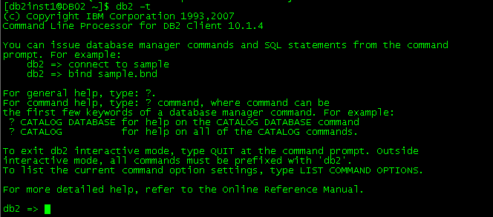

CREATE LARGE TABLESPACE "DATA_TBS1" IN DATABASE PARTITION GROUP IBMDEFAULTGROUP PAGESIZE 32768 MANAGED BY DATABASE

USING (FILE '/etl/db2inst1/etldb/tbsdata/DATA_TBS1_01.DBF' 163840,

FILE '/etl/db2inst1/etldb/tbsdata/DATA_TBS1_02.DBF' 163840)

EXTENTSIZE 64

PREFETCHSIZE AUTOMATIC

BUFFERPOOL BP_DATA_32K

NO FILE SYSTEM CACHING

DROPPED TABLE RECOVERY ON;

CREATE LARGE TABLESPACE "IDX_TBS1" IN DATABASE PARTITION GROUP IBMDEFAULTGROUP PAGESIZE 32768 MANAGED BY DATABASE

USING (FILE '/etl/db2inst1/etldb/tbsdata/IDX_TBS1_01.DBF' 163840)

EXTENTSIZE 64

PREFETCHSIZE AUTOMATIC

BUFFERPOOL BP_IDX_32K

NO FILE SYSTEM CACHING

DROPPED TABLE RECOVERY ON;

CREATE LARGE TABLESPACE "LONG_TBS1" IN DATABASE PARTITION GROUP IBMDEFAULTGROUP PAGESIZE 32768 MANAGED BY DATABASE

USING (FILE '/etl/db2inst1/etldb/tbsdata/LONG_TBS1_01.DBF' 163840)

EXTENTSIZE 64

PREFETCHSIZE AUTOMATIC

BUFFERPOOL BP_DATA_32K

NO FILE SYSTEM CACHING

DROPPED TABLE RECOVERY ON;

CREATE LARGE TABLESPACE "DATA_TBS2" IN DATABASE PARTITION GROUP IBMDEFAULTGROUP PAGESIZE 8192 MANAGED BY DATABASE

USING (FILE '/etl/db2inst1/etldb/tbsdata/DATA_TBS2_01.DBF' 262144)

EXTENTSIZE 64

PREFETCHSIZE AUTOMATIC

BUFFERPOOL BP_DATA_8K

NO FILE SYSTEM CACHING

DROPPED TABLE RECOVERY ON;

CREATE LARGE TABLESPACE "IDX_TBS2" IN DATABASE PARTITION GROUP IBMDEFAULTGROUP PAGESIZE 8192 MANAGED BY DATABASE

USING (FILE '/etl/db2inst1/etldb/tbsdata/IDX_TBS2_01.DBF' 131072)

EXTENTSIZE 64

PREFETCHSIZE AUTOMATIC

BUFFERPOOL BP_IDX_8K

NO FILE SYSTEM CACHING

DROPPED TABLE RECOVERY ON;

CREATE TEMPORARY TABLESPACE "TMP_TBS1"

IN DATABASE PARTITION GROUP "IBMTEMPGROUP"

PAGESIZE 32K

MANAGED BY SYSTEM

USING

('/etl/db2inst1/etldb/tbsdata/TMP_TBS1'

)

EXTENTSIZE 64

PREFETCHSIZE AUTOMATIC

BUFFERPOOL "BP_DATA_32K"

NO FILE SYSTEM CACHING;

CREATE REGULAR TABLESPACE "EOS4KTS" IN DATABASE PARTITION GROUP IBMDEFAULTGROUP PAGESIZE 4096 MANAGED BY DATABASE

USING (FILE '/etl/db2inst1/etldb/tbsdata/EOS4KTS.dbf' 2621440)

EXTENTSIZE 64

PREFETCHSIZE AUTOMATIC

BUFFERPOOL EOS4K

NO FILE SYSTEM CACHING

DROPPED TABLE RECOVERY ON;

CREATE REGULAR TABLESPACE "EOS32KTS" IN DATABASE PARTITION GROUP IBMDEFAULTGROUP PAGESIZE 32768 MANAGED BY DATABASE

USING (FILE '/etl/db2inst1/etldb/tbsdata/EOS32KTS.dbf' 163840)

EXTENTSIZE 64

PREFETCHSIZE AUTOMATIC

BUFFERPOOL EOS32K

NO FILE SYSTEM CACHING

DROPPED TABLE RECOVERY ON;

删除USERSPACE1

drop tablespace USERSPACE1;



## 修改数据库参数

db2 update db cfg for etldb using CATALOGCACHE_SZ 2048

db2 update db cfg for etldb using LOGBUFSZ 4096

db2 update db cfg for etldb using LOGFILSIZ 25600

db2 update db cfg for etldb using LOGPRIMARY 20

db2 update db cfg for etldb using LOGARCHMETH1 LOGRETAIN

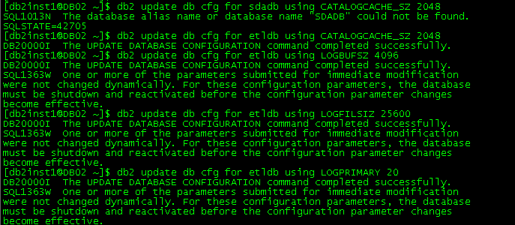

重新启动实例，db2stop force

db2start

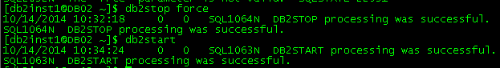

db2 connect to etldb;



报错之后,进行数据库备份:

db2 backup db etldb to /home/db2inst1



## HADR配置

使用root用户登录另一台机器：57机器，执行上面的相同的操作2.1、2.2、2.3、2.4、2.5、1.6步后。

db2inst1用户登录51.64.0.36机器,执行数据库备份：

db2 backup db etldb to /home/db2inst1



将镜像文件拷贝至51.64.0.37机器上的/home/db2inst1目录下：

使用db2inst1用户登录51.64.0.37机器，利用数据库备份恢复至51.64.0.37机器上：

db2 restore db etldb from /home/db2inst1



归档日志模式恢复备份数据库后，不要进行前滚操作。

备数据库恢复后，务必不要连接数据库，否则HADR启动会失败。

51.64.0.37机器数据库恢复完毕。

使用root用户分别登录56、57机器，vi打开/etc/services文件，在最后加入下面一行内容：

db2h_db2inst1 51000/tcp #db2 hadr service port

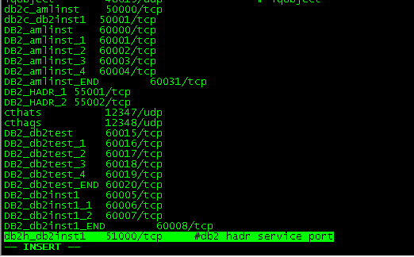

使用db2inst1在51.64.0.36机器执行以下命令：

db2 update db cfg for etldb using HADR_LOCAL_HOST ETL1

db2 update db cfg for etldb using HADR_LOCAL_SVC db2h_db2inst1

db2 update db cfg for etldb using HADR_REMOTE_HOST ETL2

db2 update db cfg for etldb using HADR_REMOTE_SVC db2h_db2inst1

db2 update db cfg for etldb using HADR_REMOTE_INST db2inst1

db2 update db cfg for etldb using LOGINDEXBUILD ON

db2 update db cfg for etldb using INDEXREC RESTART

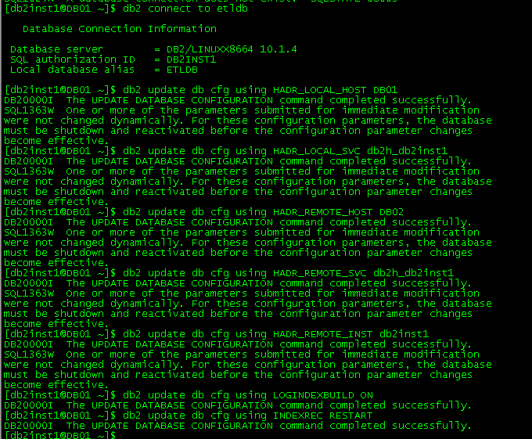

使用db2inst1在51.64.0.37机器执行以下命令：

db2 update db cfg for etldb using HADR_LOCAL_HOST ETL2

db2 update db cfg for etldb using HADR_LOCAL_SVC db2h_db2inst1

db2 update db cfg for etldb using HADR_REMOTE_HOST ETL1

db2 update db cfg for etldb using HADR_REMOTE_SVC db2h_db2inst1

db2 update db cfg for etldb using HADR_REMOTE_INST db2inst1

db2 update db cfg for etldb using LOGINDEXBUILD ON

db2 update db cfg for etldb using INDEXREC RESTART

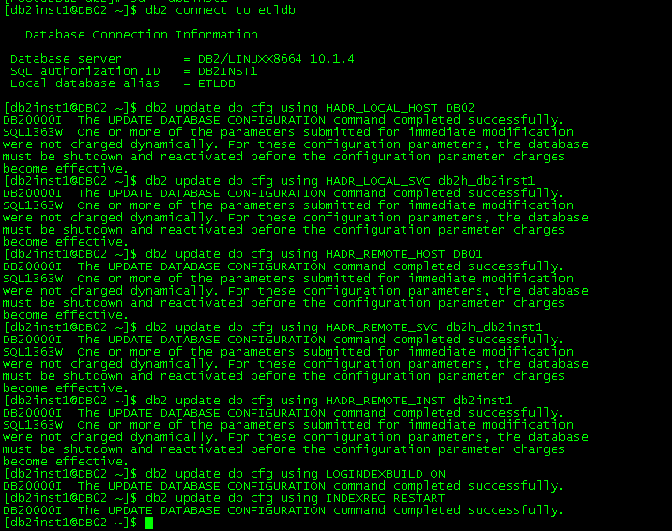

使用db2inst1用户分别登录36/37机器，执行：

[db2inst1@DB01 ~]$ db2set DB2_HADR_ROS=ON

[db2inst1@DB01 ~]$ db2set DB2_STANDBY_ISO=UR



启动51.64.0.37机器的备数据库：

db2 start hadr on db etldb as standby



启动51.64.0.36机器的主数据库：

db2 start hadr on db etldb as primary



## etl用户环境和权限控制

**授予ETL用户数据库ADM权限：**

db2 "GRANT DBADM ON DATABASE TO USER etl"

etl用户登录:

vi .bashrc

添加如下内容：

# The following three lines have been added by UDB DB2.

if [ -f /home/db2inst1/sqllib/db2profile ]; then

. /home/db2inst1/sqllib/db2profile

fi

## TSA安装及配置

root用户登录：

cd /opt/tools/server/db2/linuxamd64/tsamp

./prereqSAM

./installSAM

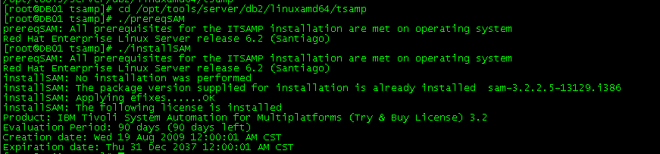

安装ssh补丁(略)

分别用root和db2inst1用户登录,配置ssh无密码访问：

rm -rf .ssh

mkdir .ssh

cd .ssh

ssh-keygen -t rsa

scp id_rsa.pub db02:/home/db2inst1/.ssh/id_rsa.pub.db01

mkdir .ssh

cd .ssh

ssh-keygen -t rsa

scp id_rsa.pub db01:/home/db2inst1/.ssh/id_rsa.pub.db02

cat id_rsa.pub* >> authorized_keys

--设置preprpnode

/usr/sbin/rsct/bin

--root用户执行

--节点DB01

ssh DB01 preprpnode DB01 DB02

ssh DB02 preprpnode DB01 DB02

--节点StandbyNode

ssh DB01 preprpnode DB01 DB02

ssh DB02 preprpnode DB01 DB02

db2inst1用户执行：

db2 update db cfg using HADR_PEER_WINDOW 120

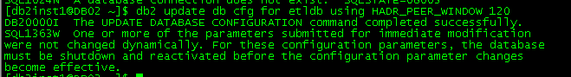

root用户执行

检查是否存在 /usr/sbin/rsct/sapolicies/db2



cd /opt/ibm/db2/V10.1/install/tsamp

./db2cptsa

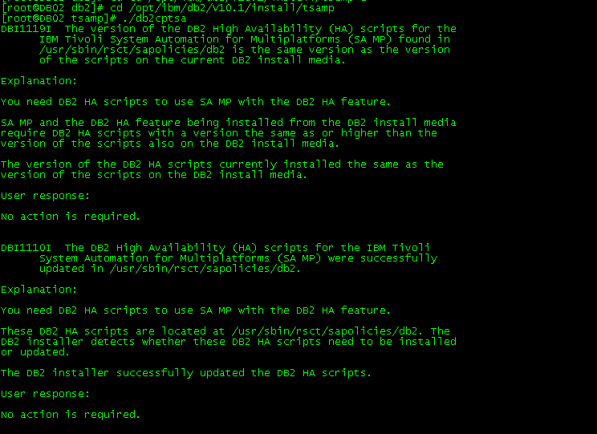

db2inst1用户登录57从节点:

cd ~/sqllib/bin

./db2haicu

[db2inst1@DB02 bin]$ ./db2haicu

Welcome to the DB2 High Availability Instance Configuration Utility (db2haicu).

You can find detailed diagnostic information in the DB2 server diagnostic log file called db2diag.log. Also, you can use the utility called db2pd to query the status of the cluster domains you create.

For more information about configuring your clustered environment using db2haicu, see the topic called 'DB2 High Availability Instance Configuration Utility (db2haicu)' in the DB2 Information Center.

db2haicu determined the current DB2 database manager instance is 'db2inst1'. The cluster configuration that follows will apply to this instance.

db2haicu is collecting information on your current setup. This step may take some time as db2haicu will need to activate all databases for the instance to discover all paths ...

When you use db2haicu to configure your clustered environment, you create cluster domains. For more information, see the topic 'Creating a cluster domain with db2haicu' in the DB2 Information Center. db2haicu is searching the current machine for an existing active cluster domain ...

db2haicu did not find a cluster domain on this machine. db2haicu will now query the system for information about cluster nodes to create a new cluster domain ...

db2haicu did not find a cluster domain on this machine. To continue configuring your clustered environment for high availability, you must create a cluster domain; otherwise, db2haicu will exit.

Create a domain and continue? [1]

1. Yes

2. No

1

Create a unique name for the new domain:

domain13

Nodes must now be added to the new domain.

How many cluster nodes will the domain 'domain13' contain?

2

Enter the host name of a machine to add to the domain:

DB01

Enter the host name of a machine to add to the domain:

DB02

db2haicu can now create a new domain containing the 2 machines that you specified. If you choose not to create a domain now, db2haicu will exit.

Create the domain now? [1]

1. Yes

2. No

1

Creating domain 'domain13' in the cluster ...

Creating domain 'domain13' in the cluster was successful.

You can now configure a quorum device for the domain. For more information, see the topic "Quorum devices" in the DB2 Information Center. If you do not configure a quorum device for the domain, then a human operator will have to manually intervene if subsets of machines in the cluster lose connectivity.

Configure a quorum device for the domain called 'domain13'? [1]

1. Yes

2. No

1

The following is a list of supported quorum device types:

1. Network Quorum

Enter the number corresponding to the quorum device type to be used: [1]

1

Specify the network address of the quorum device:

172.21.36.2

Configuring quorum device for domain 'domain13' ...

Configuring quorum device for domain 'domain13' was successful.

The cluster manager found the following total number of network interface cards on the machines in the cluster domain: '6'. You can add a network to your cluster domain using the db2haicu utility.

Create networks for these network interface cards? [1]

1. Yes

2. No

1

Enter the name of the network for the network interface card: 'Bond1' on cluster node: 'DB01'

1. Create a new public network for this network interface card.

2. Create a new private network for this network interface card.

Enter selection:

2

Are you sure you want to add the network interface card 'Bond1' on cluster node 'DB01' to the network 'db2_private_network_0'? [1]

1. Yes

2. No

1

Adding network interface card 'Bond1' on cluster node 'DB01' to the network 'db2_private_network_0' ...

Adding network interface card 'Bond1' on cluster node 'DB01' to the network 'db2_private_network_0' was successful.

Enter the name of the network for the network interface card: 'vlan901' on cluster node: 'DB01'

1. db2_private_network_0

2. Create a new public network for this network interface card.

3. Create a new private network for this network interface card.

Enter selection:

2

Are you sure you want to add the network interface card 'vlan901' on cluster node 'DB01' to the network 'db2_public_network_0'? [1]

1. Yes

2. No

1

Adding network interface card 'vlan901' on cluster node 'DB01' to the network 'db2_public_network_0' ...

Adding network interface card 'vlan901' on cluster node 'DB01' to the network 'db2_public_network_0' was successful.

Enter the name of the network for the network interface card: 'Bond1' on cluster node: 'DB02'

1. db2_public_network_0

2. db2_private_network_0

3. Create a new public network for this network interface card.

4. Create a new private network for this network interface card.

Enter selection:

2

Are you sure you want to add the network interface card 'Bond1' on cluster node 'DB02' to the network 'db2_private_network_0'? [1]

1. Yes

2. No

1

Adding network interface card 'Bond1' on cluster node 'DB02' to the network 'db2_private_network_0' ...

Adding network interface card 'Bond1' on cluster node 'DB02' to the network 'db2_private_network_0' was successful.

Enter the name of the network for the network interface card: 'Bond0' on cluster node: 'DB01'

1. db2_public_network_0

2. db2_private_network_0

3. Create a new public network for this network interface card.

4. Create a new private network for this network interface card.

Enter selection:

1

Are you sure you want to add the network interface card 'Bond0' on cluster node 'DB01' to the network 'db2_public_network_0'? [1]

1. Yes

2. No

1

Adding network interface card 'Bond0' on cluster node 'DB01' to the network 'db2_public_network_0' ...

Adding network interface card 'Bond0' on cluster node 'DB01' to the network 'db2_public_network_0' was successful.

Enter the name of the network for the network interface card: 'vlan901' on cluster node: 'DB02'

1. db2_public_network_0

2. db2_private_network_0

3. Create a new public network for this network interface card.

4. Create a new private network for this network interface card.

Enter selection:

2

Are you sure you want to add the network interface card 'vlan901' on cluster node 'DB02' to the network 'db2_private_network_0'? [1]

1. Yes

2. No

1

Adding network interface card 'vlan901' on cluster node 'DB02' to the network 'db2_private_network_0' ...

Adding network interface card 'vlan901' on cluster node 'DB02' to the network 'db2_private_network_0' was successful.

Enter the name of the network for the network interface card: 'Bond0' on cluster node: 'DB02'

1. db2_public_network_0

2. db2_private_network_0

3. Create a new public network for this network interface card.

4. Create a new private network for this network interface card.

Enter selection:

2

Are you sure you want to add the network interface card 'Bond0' on cluster node 'DB02' to the network 'db2_private_network_0'? [1]

1. Yes

2. No

7

Are you sure you want to add the network interface card 'Bond0' on cluster node 'DB02' to the network 'db2_private_network_0'? [1]

1. Yes

2. No

1

Adding network interface card 'Bond0' on cluster node 'DB02' to the network 'db2_private_network_0' ...

Adding network interface card 'Bond0' on cluster node 'DB02' to the network 'db2_private_network_0' was successful.

Retrieving high availability configuration parameter for instance 'db2inst1' ...

The cluster manager name configuration parameter (high availability configuration parameter) is not set. For more information, see the topic "cluster_mgr - Cluster manager name configuration parameter" in the DB2 Information Center. Do you want to set the high availability configuration parameter?

The following are valid settings for the high availability configuration parameter:

1.TSA

2.Vendor

Enter a value for the high availability configuration parameter: [1]

1

Setting a high availability configuration parameter for instance 'db2inst1' to 'TSA'.

Adding DB2 database partition '0' to the cluster ...

Adding DB2 database partition '0' to the cluster was successful.

Do you want to validate and automate HADR failover for the HADR database 'ETLDB'? [1]

1. Yes

2. No

1

Adding HADR database 'ETLDB' to the domain ...

HADR database 'ETLDB' has been determined to be valid for high availability. However, the database cannot be added to the cluster from this node because db2haicu detected this node is the standby for HADR database 'ETLDB'. Run db2haicu on the primary for HADR database 'ETLDB' to configure the database for automated failover.

All cluster configurations have been completed successfully. db2haicu exiting ...

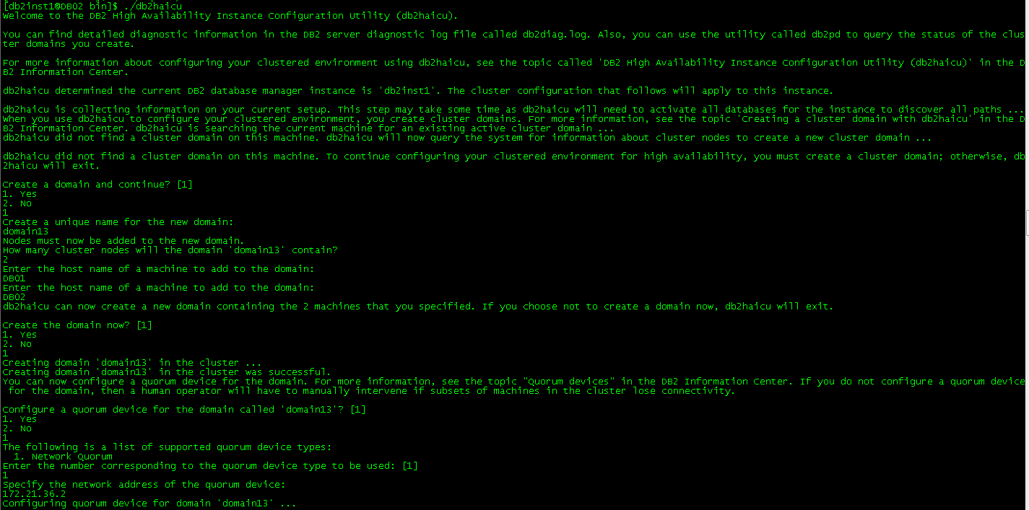

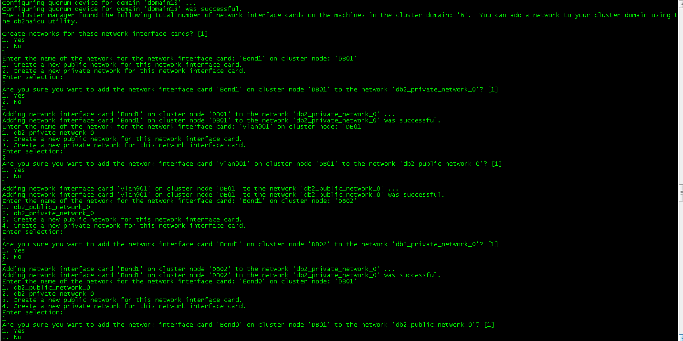

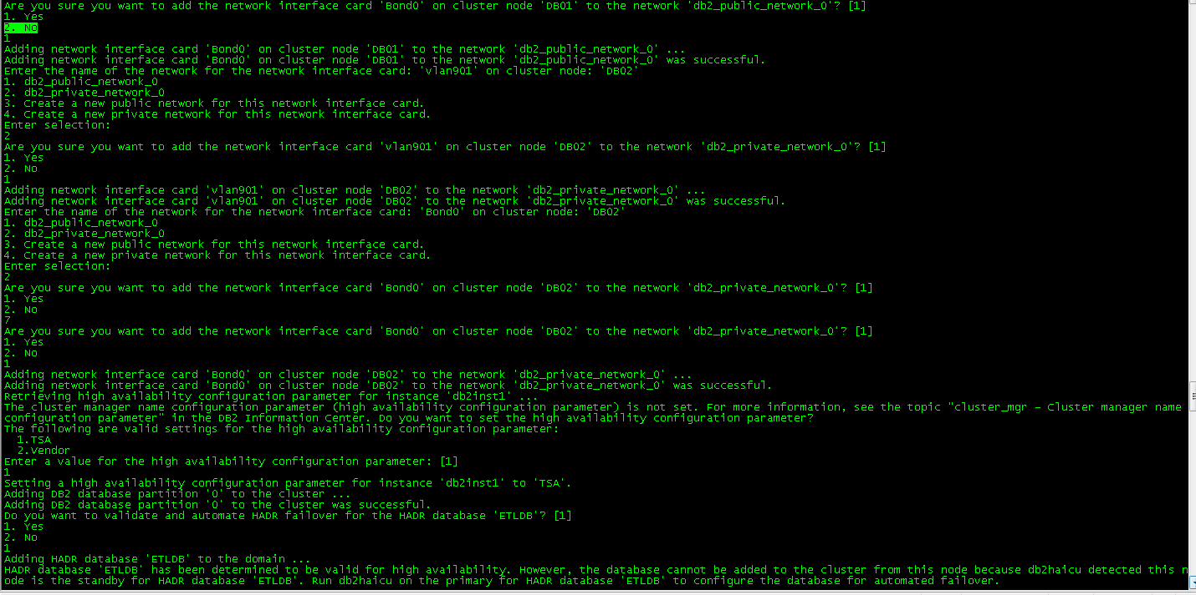

db2inst1用户登录56主节点:

cd ~/sqllib/bin